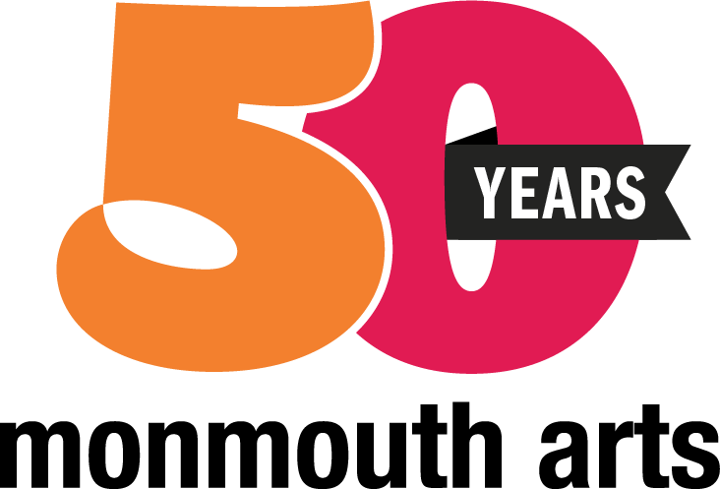

**FOR IMMEDIATE RELEASE: October 15, 2024**

Connie Isbell, Monmouth Arts

connie@monmoutharts.org

**Monmouth Arts Announces Recipients of ArtHelps Funding for 2025**

(Red Bank, NJ) -- Monmouth Arts is pleased to announce the ArtHelps Local Arts Program Awards for Fiscal Year 2025 through a partnership with the New Jersey State Council on the Arts. These competitive grants are awarded to local nonprofit arts organizations that provide high-quality art programs and events to residents throughout Monmouth County each year.

​

Monmouth Arts is awarding more than $135,000 to a total of 29 organizations for general operating and special project support; the total also includes eight Mini Grants of $500 each that will be available in 2025 for arts projects by small and emerging organizations. Eligible recipients of ArtHelps grants include Monmouth County nonprofit arts organizations and community groups with arts programs that provide excellent arts events that are accessible and beneficial to the public.

Monmouth Arts congratulates the 29 recipients for 2025: Arcadian Chorale, Art Alliance of Monmouth County, Asbury Park African American Music Project, Asbury Park Arts Council, Asbury Park Dance Festival, Asbury Park Music Foundation, Atlantic Highlands Arts Council, Brookdale Community College Foundation, Company of Dance Arts, Creative OPERAtions, Guild of Creative Art, Heart of New Jersey Chorus, Hellenic Dancers of New Jersey, Holmdel Theatre Company, Indie Street Film Festival, Jazz Arts Project, Jersey Shore Arts Center, LongFellow Deeds, Monmouth Civic Chorus, Monmouth County Diversity Alliance, Pipes & Drums of the Atlantic Watch, Premier Theatre Company, Red Bank Chamber Music Society, Red Bank Parks and Recreation, Red Bank Theatre for Young Audiences of the UMCRB, Shrewsbury Chorale, T. Thomas Fortune Foundation, The Allentown Village Initiative, and the Wooden Walls Public Art Project.

Grant applications were evaluated based on Monmouth Arts’ updated funding priorities, which include promoting cultural equity, diversity, and inclusion; forging partnerships and collaborations among individuals or organizations; broadening public participation; advancing and advocating for arts education in schools and life-long learning; and preserving and conserving art forms and cultural heritage.

"Monmouth Arts is pleased to support these exceptional Monmouth County arts organizations through our ArtHelps Local Arts Program," says Monmouth Arts Executive Director Teresa Staub. “This year, we are delighted to announce an increase in our grant funding, which will provide valuable support for the growth and development of our arts community. We thank the New Jersey State Council on the Arts and Governor Murphy for their continued investment in our creative community."

Monmouth Arts is a leading, independent 501c(3) arts advocacy organization that delivers needed programs and services to artists, member organizations, and arts affiliates to ensure the arts thrive in and throughout Monmouth County. As Monmouth County’s official county arts agency, its mission is to enrich the community by inspiring and fostering the arts. Monmouth Arts' programs are made possible in part through funding from the Monmouth County Board of Chosen Commissioners, the Geraldine R. Dodge Foundation, and the New Jersey State Council on the Arts. For more information on Monmouth Arts, call 732-212-1890 or visit [www.monmoutharts.org](http://www.monmoutharts.org).

Monmouth Arts is fully committed to providing equal access for all of its patrons, employees, and the public. Upon request, Monmouth Arts will make the necessary accommodations to allow individuals with special needs to participate in Monmouth Arts services, programs, and activities to the fullest extent possible. For more information, refer to the Accessibility page on our website [www.monmoutharts.org/accessibility](http://www.monmoutharts.org/accessibility).

###